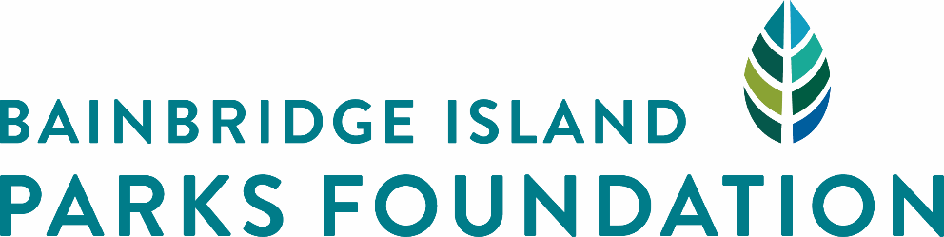
PO BOX 11127
BAINBRIDGE ISLAND, WA 98110
WWW.BIPARKSFOUNDATION.ORG

COMMUNITY GRANT DESCRIPTION AND CRITERIA
Submission deadline: October 1, 2018

The Bainbridge Island Parks Foundation (BIPF) created the Community Grant Program to encourage and support qualiﬁed non-proﬁts, individuals and community groups who want to undertake projects to improve and enhance trails, parks, facilities and recreational opportunities on Bainbridge Island. The Bainbridge Island Parks Foundation is a 501(c)(3) nonproﬁt organization whose mission is to enhance community by supporting a thriving system of parks, trails and open space.

GOALS OF THE COMMUNITY GRANT PROGRAM:

- To improve Bainbridge Island parks and trails in ways that reﬂect community priorities.
- To inspire partnerships that provide stewardship of Bainbridge Island parks and trails.
- To help deﬁne community goals for our parks while educating the public as to needs and opportunities of Bainbridge Island parks, trails and facilities.

GRANT AMOUNTS AVAILABLE:

2018 Bainbridge Island Parks Foundation Community Grants anticipated limit is $3500 per award and may be smaller depending on the number of awards granted. Community Grants are limited to capital projects, not operating expenses or budgets already in place for recreational programs.

WHO MAY APPLY:

Individuals, families, neighborhood and community groups, private businesses, organized recreation groups, and philanthropic organizations are all welcome to apply for funding for projects which enhance parks, trails and open space, or improve recreational opportunities on Bainbridge Island. Individuals and groups who apply without nonproﬁt status must partner with a public agency where the project will be located, such as the Bainbridge Island Metropolitan Park & Rec District. A public agency may apply, and must partner with a community representative, to assure community interest in the project.
GRANT CRITERIA includes but is not limited to projects which:

- Address a deﬁnable community need and beneﬁt the public.
- Occur in or on a park, trail or public space, or park facility on Bainbridge Island, and/or correlate to Park District recreational programs.
- Enhance public use of Bainbridge Island parks, trails and facilities.
- Include a well-organized, realistic budget and schedule.
- Include plans that specify an appropriate location, installation, and maintenance plan.
- Be completed by September 30, 2019 unless otherwise granted an extension or renegotiated with BIPF’s Community Grant Committee.
- Align with the Comprehensive Plan approved by the Bainbridge Island Metropolitan Park & Recreation District (or City or School District- as property owner), or otherwise given special approval before a grant may be awarded.

APPLICATION PROCESS:

Interested applicants must complete BIPF’s Community Grant Application by October 1, 2018.
BIPF’s Community Grant Committee will review all completed applications. The Committee will invite top applicants to give a ﬁve minute presentation on the evening of October 16, 2018. Please reserve time on this evening for a member of your project team to present, and for a short Q&A session. The Committee will then evaluate and recommend grant awards to BIPF’s Board of Directors for approval. Awards will be based on meeting the criteria and requirements set out above and funding availability. Once the awards have been announced, BIPF will send grantees a formal Grant Agreement to be executed by both parties.

FOR MORE INFORMATION OR ASSISTANCE:
Questions about this application can be directed to the Bainbridge Island Parks Foundation
Executive Director Barbara Trafton via email at barb@biparksfoundation.org.

